Hornby Cricket Club

Established

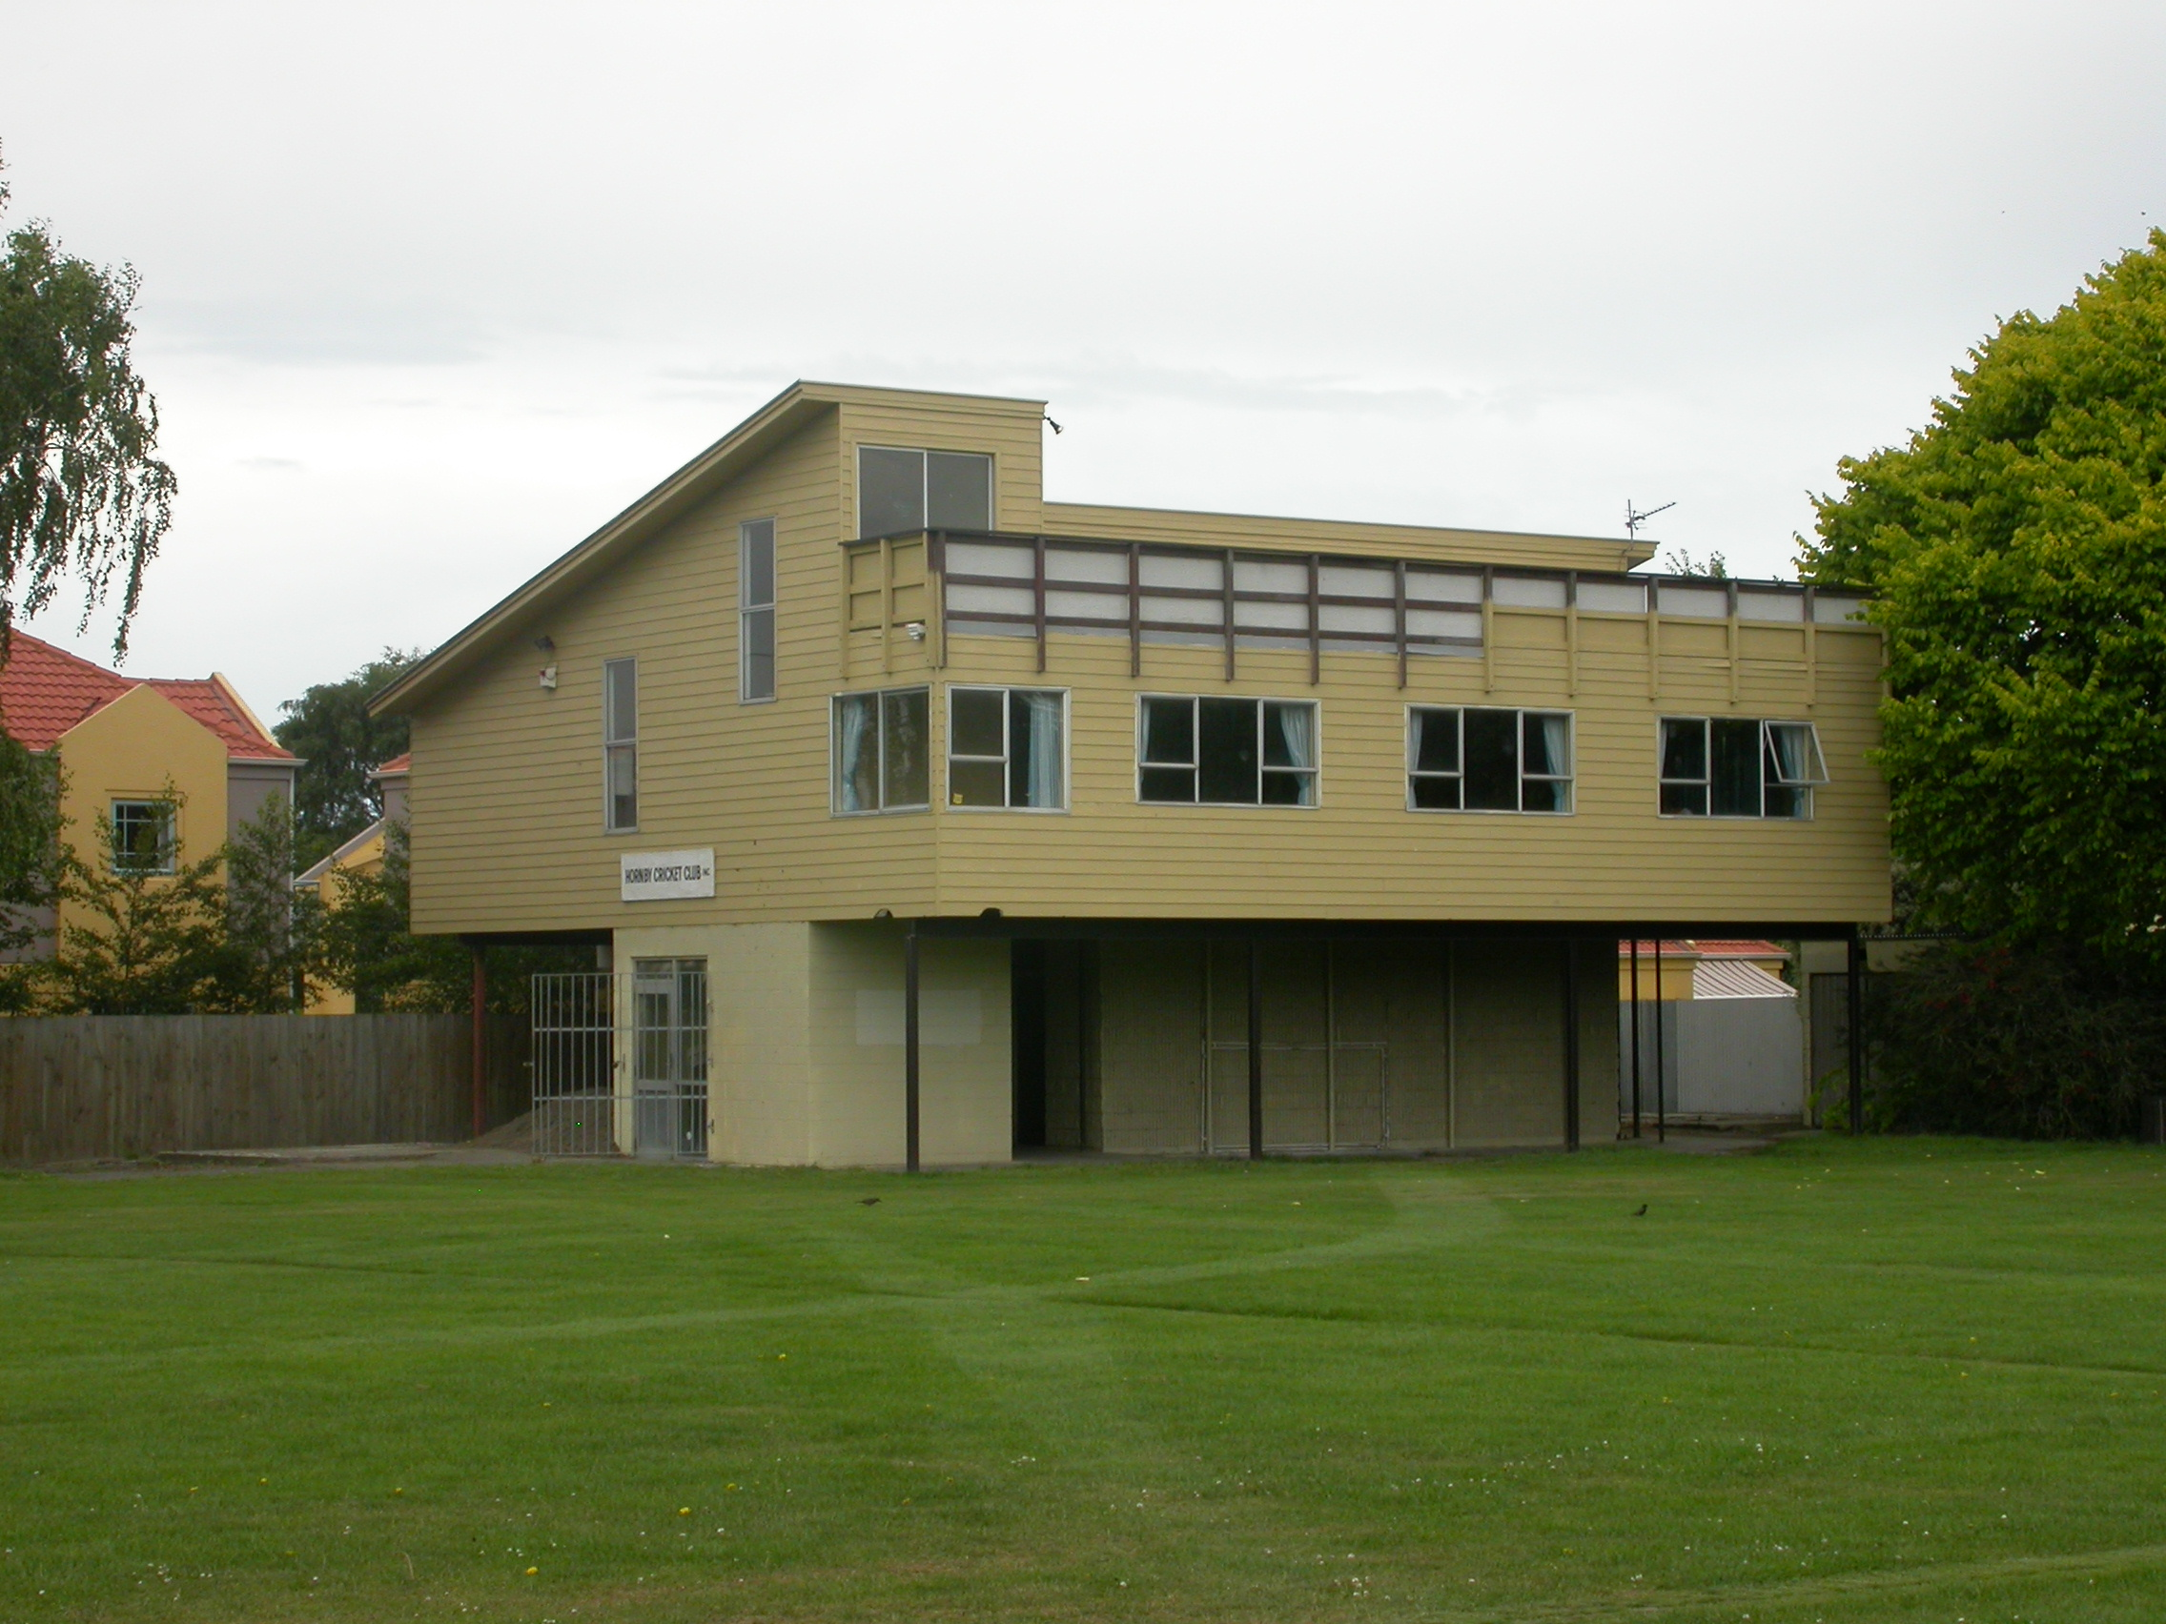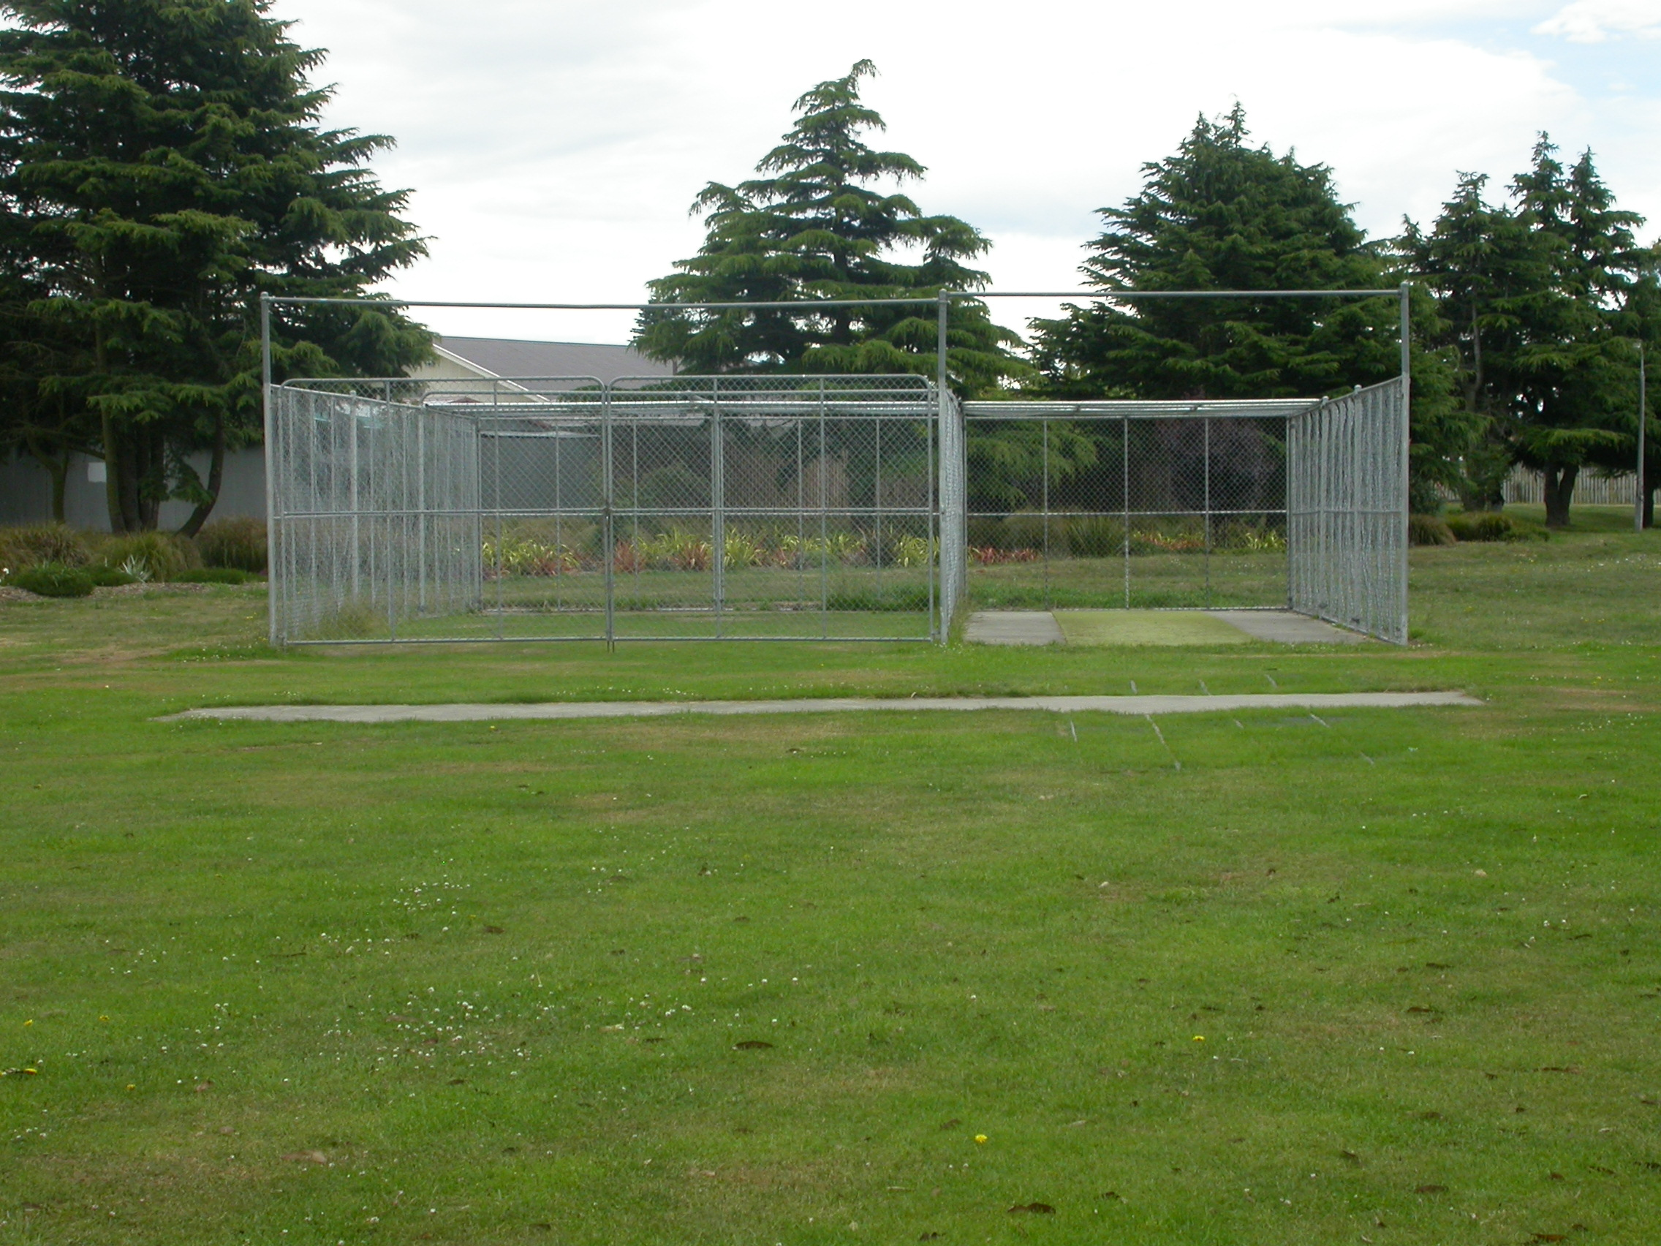

Home Ground Denton Oval
Match pitches 4 grass match pitches
Practice pitches 1 grass pitch 1 artificial pitch

Entries 2001-02 5 men teams 1 women team 7 junior teams
2002-03 5 men teams 1 women team 6 junior teams
2003-04 4 men teams 2 women team 6 junior teams
2004-05 5 men teams 1 women team 4 junior teams
2005/06 4 men teams 1 women team 4 junior teams
Grade wins last 5 years
Men 2000-01 Third B Fourth C
2001-02 Third C
2002-03 Third C Fourth A
2003-04 Senior B
2004-05 Second grade
Women 2002-03 Fourth grade
2003-04 Third grade

